**Tim’s Traffic Control**

**Group 8**

**Jumanah al Awfi, Iana Lazareva**

*TABLE OF CONTENTS*

Context description: 3

Stakeholder analysis￼ 4

Requirements: 7

User requirements 7

Business requirements: 9

Functional requirements: 10

Non-functional requirements: 12

Diagrams and models 14

System context diagram 14

System architecture diagram: 14

Use case diagram + elaboration 15

Domain model: 19

Activity diagram: 20

User stories 21

All user stories with effort: 21

￼All sprint 1 user stories: 21

14 Elaborated user stories: 21

Test cases: 28

All test cases: 28

Elaborated test cases: 28

Traceability matrix 32

Wireframes: 34

For customer: 34

For administrator: 34

For controller: 34

￼Appendix A 34

# Context description:

The "Tim's traffic controller" company is looking for a new management system to replace their current paper-based system.

The company provides controllers to customers for their traffic events. The owner of a company is Tim Bootsma.

The company has two types of employees. Controllers who work during events. Administrators manage the controllers and handle all the administrative tasks including the finances.

Controllers and Administrators earn a fixed wage. Administrators need to keep a timesheet. The controllers should be able to manage their own timesheet via the application.

The administrator creates and checks this timesheet. The maximum working hours for controllers per day is 10 hours.

The company expects the application to be delivered as a web app for customers and administrators, and as an application for employees. It should be functional on all devices. The interface needs to be clear and straightforward, in that no training should be necessary for employees to use the system.

The system should be safe to use and secure so that no unauthorized access to the system is possible. Employees should not be able to see each other’s data. The data should be adequately backed up.

The system should also be fast. People don’t like waiting so loading should not take more than 3 seconds and it should be available 24/7.

# Stakeholder analysis

|  |  |  |  |  |  |  |
| --- | --- | --- | --- | --- | --- | --- |
|  | **Role and importance.** | **What position does the Stakeholder have?** | **Knowledge level of the stakeholder of the subject?** | **Interest of the stakeholder in the initiative?** | **Sources available for stakeholders and possibility to use them** | **Willingness to take initiative or lead.?** |
| **Customers** | The role of a customer is booking a service, they are important because the they drive revenues, without them; the business cannot continue to exist. | External | low | Interested in the quality of controlling services and their value. | Website, it is where they can book for a trafficking service. | No, they have no experience in the trafficking business |
| **Traffic controllers** | They manage trafficking events and organize them. | Internal | mid | Deliver service, and interested in getting paid and being offered job security | The app is where they can access and check their scheduled bookings. | Yes, they have a lot of knowledge in this business, however they still require further training in administration |
| **Administrators** | They manage and assign tasks to controllers as well as manage invoices. | Internal | mid | Manage tasks and controllers, and interested in getting paid and being offered job security | The website, since they have their section and pages to track and confirm tasks. They also use excel to upload and manage timesheets. | Yes, they have a lot of knowledge in this business, however they still require further training in controlling aspect |
| **Owner Tim** | He gives instructions to all employees and controllers | Internal | high | Successful business growth and making profit. | Tim will often be involved and reached out to by email from the admin workers. | Yes, he has enough knowledge since he is the owner |
| **Developers** | They develop the website and application for Tim's business | External | mid | Develop IT solutions (website / app) and interested in getting paid. | Emails and meetings, they would tend to work online, and get reached out to through mail or email | No, they have no experience in the trafficking business. they are only interested in the IT aspect. |
| **Government** | They provide the business with the GDPR laws and demand tax | External | low | Interested in getting tax money and having the rules and regulations obeyed by company | Post mail usually will send tax bills by post mail. | No, they have no experience in the trafficking business. |

Stakeholders in section A:

* Customers. (Order events)

Stakeholders in section B:

* Owner. (The initiator of the project. The most important person.)
* Admin. (The system will change their way of working. A very important source of information)
* Controllers. (Will have to use the system. An important source of information)

Stakeholders in section C:

* Suppliers. (Supply items for controllers)
* Developers. (Will develop the system. Their choices will influence the lives of the other actors. But will not be using the system)

Stakeholders in section D:

* Government.

These stakeholders had been categorized in the following Power Influence Matrix:

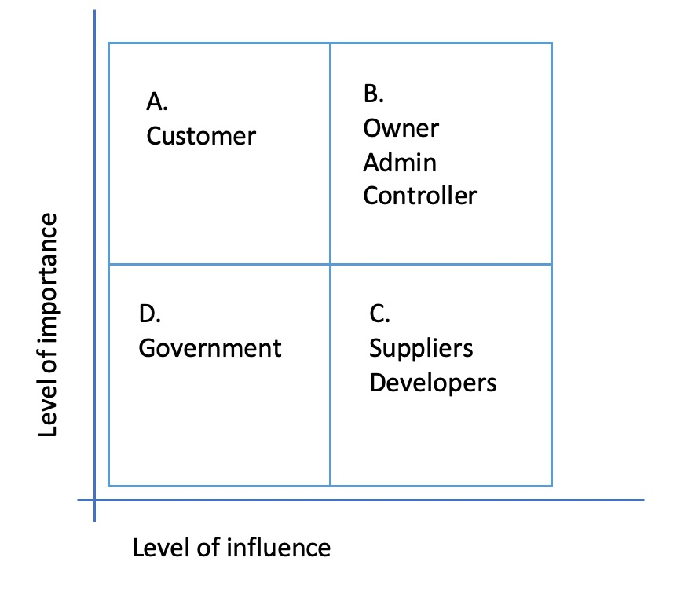

# Requirements:

|  |
| --- |
| B - business  U - user  F – functional  NF – non functional  Tasks – employee's own work  Refer to Appendix A for interview questions. |

## User requirements

|  |  |  |  |  |
| --- | --- | --- | --- | --- |
| No. | Description | Source | ISO | Moscow |
| U1 | The customers shall be able to view and book all kinds of trafficking services through a website | interview | FS | M |
| U2 | The admin shall manage all their tasks and responsibilities through a website. | interview | FS | M |
| U 3 | The controllers shall view and check their tasks through an app. | interview | FS | M |
| U4 | If a customer wants to book a service, they shall click on the “services” button on the top of the homepage. | extra | FS | M |
| U5 | If a customer clicks on the “services” button, a friendly message should appear, which suggests that the customer should register or login first. | extra | FS | M |
| U6 | If the customer clicks on the “login” button, they will be asked to fill in an email and a password. | interview | FS | M |
| U7 | On the login page and right after the user fills in their details, there will be a “remember me” tick box, in which users can click on to be remembered and don’t have to fill in their password, the next time they login. | interview | FS | M |
| U8 | If the user clicks on the “register” button, they will be asked to fill in an email and a password. And an employee number (in case the user is an employee), as well as their date of birth. | extra | FS | M |
| U9 | Next to the services button will be a frequently asked questions button which leads to a new separate page containing the commonly asked questions and answers. | interview | FS | M |
| U10 | If the customer wishes to know more about the business, they shall click on the “about us” button | extra | FS | M |
| U11 | The “about us” button shall open a page where further information and background is given about the business. | extra | FS | M |
| U12 | Once the job is successfully done, the customer will only have the option to pay by card. | interview | FS | M |
| U13 | if the user clicks on the language (flag) button, the system will display three other options of languages to choose from: German, Dutch and Turkish from the top right corner of the page. | interview | FS | M |
| U14 | If the customer manages to login successfully, they shall click on the home button. Then be directed to a customer homepage. | extra | FS | M |
| U15 | If the customer clicks on “your page” at the top right corner, the web page will display their personal information which includes full name, email, phone number and date of birth. | extra | FS | M |
| U16 | If the customer clicks on “my orders” all their orders with their current status will be displayed. (Confirmed or to be checked) | extra | FS | S |
| U17 | If the customer clicks on “my invoices” all their invoices with their current status will be displayed. (Paid or to pay) | extra | FS | S |
| U18 | If the customer wishes to book a service, they shall click on the “services” button in the customer homepage. A calendar and time block will appear. | extra | FS | M |
| U19 | Once a controller opens the application, they have an option to either register or login. | interview | FS | M |
| U20 | When a customer clicks on the “service” button, the system will offer to choose the date, time and address for his event. | extra | FS | M |
| U21 | If the controller clicks on the “login” button, they will be asked to fill in an email and a password. | interview | FS | M |
| U22 | On the login page for the controller, there will be a “remember me” tick box, in which controllers can click on to be remembered and don’t have to fill in their password, the next time they login. | interview | FS | M |
| U23 | If the controller login is successful, 3 buttons will appear on the screen: your page, events and salary. | extra | FS | M |
| U24 | If the controller clicks on “your page”, the app will display his personal information which includes full name, email, phone number and date of birth. | extra | FS | M |
| U25 | If the controller clicks on “events” he will be directed to a calendar that displays all the upcoming events. | extra | FS | M |
| U26 | If the controller clicks on “salary” he will be directed to a page that displays their salary for the month. | extra | FS | M |
| U27 | If an admin clicks on the “login” button, they will be asked to fill in an email and a password. | extra | FS | M |
| U28 | On the login page for the admin, there will be a “remember me” tick box, in which admins can click on to be remembered and don’t have to fill in their password, the next time they login. | interview | FS | M |
| U29 | If the admin manages to login successfully, they shall click on the home button. Then be directed to an admin homepage. | extra | FS | M |
| U30 | If the admin clicks on “your page” at the top right corner, the web page will display their personal information which includes full name, email, phone number and date of birth and their position. | extra | FS | M |
| U31 | If any schedule changes happen, the system will make an announcement for all the concerned employees by email. | interview | FS | M |
| U32 | If the admin wants to access the timesheet, they can click on the timesheet button on the top of the admin homepage. | extra | FS | M |
| U33 | If the admin clicks on the timesheet button on the top of the admin homepage, a timesheet will appear on the screen that shows a timesheet based on a selected customer. | extra | FS | M |
| U34 | The admin can select a certain customer, from the drop-down filter at the top of the timesheet page. | extra | FS | M |
| U35 | If the admin wishes to export the financial data to excel, they have an option at the timesheet page | letter | FS | M |
| U36 | If administrator confirms event, the system will send a notification for customer by email. | interview | FS | M |
| U37 | If administrator confirms event, the system will send a notification for controller in the application. | interview | FS | M |
| U38 | If the admin clicks on “salary” he will be directed to a page that displays their salary. | extra | FS | M |

## Business requirements:

|  |  |  |  |  |
| --- | --- | --- | --- | --- |
| No. | Description | Source | ISO | Moscow |
| B1 | An announcement shall be sent by email if any changes in schedule occur. | Interview | FS | S |
| B2 | Once the job is successfully done, the customer will only have the option to pay by card. | letter | FS | M |
| B3 | If the admin wishes to export the timesheet to excel, they have 2 options either export a certain customer or all customers. | Interview | FS | S |
| B4 | The business wants a digital management system that replaces their current paper-based system. | letter | FS | M |

## Functional requirements:

|  |  |  |  |  |
| --- | --- | --- | --- | --- |
| No. | Description | Source | ISO | Moscow |
| F1 | The website shall have separate login page for employees and customers | interview | FS | M |
| F2 | The first page that a customer shall see when opening the website is the homepage | Extra | FS | S |
| F3 | The homepage of the customer shall have a login and register button | interview | FS | S |
| F4 | The homepage of the customer shall have an “about us” button explaining the background of the company | Extra | FS | S |
| F5 | The homepage of the customer shall have FAQ button with the most common question asked by customers | extra | FS | S |
| F6 | The logo of Tim's traffic control shall be displayed on the top right of each webpage. | extra | FS | S |
| F7 | The top right corner of the homepage will have a flag indicating the change of language | interview | FS | S |
| F8 | There should be a search box on the homepage where customers can search for services and more. | extra | FS | S |
| F9 | The system shall prompt the user to fill in username and password when user tried to login. | interview | FS | M |
| F10 | The system shall prompt a “remember me” tick box when user tries to login. | extra | FS | S |
| F11 | The system shall display all personal details of customer under the “your page” option | extra | FS | S |
| F12 | The system shall list all orders of customer and the status of each order under the “my orders” option | extra | FS | M |
| F13 | The system shall display an option to cancel each order in the list of orders | interview | FS | M |
| F14 | The system shall list all invoices of customer and the status of each order under the “my invoices” option | extra | FS | M |
| F15 | The system shall present a calendar, time block and location for customers to edit under the services button | extra | FS | M |
| F16 | The system shall display all personal details of employee under the “your page” option | extra | FS | S |
| F17 | The system shall list all salaries of employee under the “salary” option | extra | FS | S |
| F18 | Under the “timesheet” option the system shall display all the upcoming events and controller schedule. | extra | FS | M |
| F19 | The system shall display a button on the timesheet page for administrators to be able to export financial data to excel. | Interview & letter | FS | M |
| F20 | The system shall display a button on the timesheet page for administrators to be able to send notifications to customers and controllers. | extra | FS | M |
| F21 | The system shall present a calendar for each controller under the “events” option in the controller's app | extra | FS | M |
| F22 | The system shall display the monthly salary of a controller under the  ”salary” option | extra | FS | S |

## Non-functional requirements:

|  |  |  |  |  |
| --- | --- | --- | --- | --- |
| **No.** | **Description** | **Source** | **ISO** | **Moscow** |
| NF1 | The system should be accessible by people from multiple countries. | extra | Usability | M |
| NF2 | The system needs to be website that works on admin desktop | interview | Portability | M |
| NF3 | The system needs to be app that works on controller phones | interview | Portability | M |
| NF4 | Only authorized users can use the system | interview | Security | M |
| NF5 | Customers shall not see information about employees | interview | Security | M |
| NF6 | The interface needs to be clear and simple for the users | letter | Usability | S |
| NF7 | If a controller successfully completes his task and confirms it in the app, the system will generate an invoice to the customer during 5 to 9 seconds. | interview | Performance efficiency | S |
| NF8 | If a customer is a regular client, the invoice will be generated on a monthly basis by the system. | interview | Performance efficiency | S |
| NF9 | If a user clicks on the register button on the website and write employee number, the system will display pages with access to different functions/services of the website depending on the type of their work. | interview | Reliability | S |
| NF10 | During the login stage, if the user fills in a correct employee number, they will be directed to the employee page, else if it is kept empty, the system shall automatically redirect the user to the customer page. | extra | Reliability | S |
| NF11 | The option of cancelling the service will not be available to customers, once the period leading to the event is less than a week away. | interview | Reliability | S |
| NF12 | If the user clicks on the “remember me” tick box in registering page, the system will not request to enter their password next time they log in. | interview | Usability | S |
| NF13 | After the admin staff confirm the booking of the customer, the system will automatically send a task request within 4.5 secs to the controller, and they will receive it via the app. | interview | Performance efficiency | S |
| NF14 | After all finances have been finalized, the system shall have an option to export to excel. | letter | Usability | S |
| NF15 | The option of cancelling the service will not be available to controllers, once the period leading to the event is less than a week away. | interview | Reliability | S |

### Extra requirements elaboration:

|  |  |
| --- | --- |
| - If a customer wants to book a service, they shall click on the “services” button on the top of the homepage.  If a customer clicks on the “services” button, a friendly message should appear, which suggests that the customer should register or login first.  If the user clicks on the “register” button, they will be asked to fill in an email and a password. And an employee number (in case the user is an employee), as well as their date of birth.  If the customer wishes to know more about the business, they shall click on the “about us” button  The “about us” button shall open a page where further information and background is given about the business.  The homepage of the customer shall have FAQ button with the most common question asked by customers  f the customer wishes to book a service, they shall click on the “services” button in the customer homepage. A calendar and time block will appear.  During the login stage, if the user fills in a correct employee number, they will be directed to the employee page, else if it is kept empty, the system shall automatically redirect the user to the customer page.  When a customer clicks on the “service” button, the system will offer to choose the date, time and address for his event. | <https://www.trafficcontrolcompany.com> |
| If the customer manages to login successfully, they shall click on the home button. Then be directed to a customer homepage. | <https://www.superiortrafficcontrol.com/portal/login/> |
| If the customer clicks on “your page” at the top right corner, the web page will display their personal information which includes full name, email, phone number and date of birth.  The homepage of the customer shall have an “about us” button explaining the background of the company |
| If the customer clicks on “my orders” all their orders with their current status will be displayed. (Confirmed or to be checked)  The system shall list all orders of customer and the status of each order under the “my orders” option | <https://www.licences4work.com.au/traffic-control-job-network-providers-booking-form> |
| If the customer clicks on “my invoices” all their invoices with their current status will be displayed. (Paid or to pay)  The system shall list all invoices of customer and the status of each order under the “my invoices” option | <https://invoicemaker.com/templates/> |
| * If the controller login is successful, 3 buttons will appear on the screen: your page, events and salary. * if the controller clicks on “your page”, the app will display his personal information which includes full name, email, phone number and date of birth. * If the admin clicks on “salary” he will be directed to a page that displays their salary. * The system shall display all personal details of employees under the “your page” option | <https://wperp.com/13430/employee-salary-management-wordpress-payroll-plugin/> |
| If the controller clicks on “events” he will be directed to a calendar that displays all the upcoming events.  The system shall present a calendar, time block and location for customers to edit under the services button | <https://wperp.com/13430/employee-salary-management-wordpress-payroll-plugin/> |
| If the controller clicks on “salary” he will be directed to a page that displays their salary for the month.  The system shall display the monthly salary of a controller under the  ” salary” option | <https://wperp.com/13430/employee-salary-management-wordpress-payroll-plugin/> |
| If an admin clicks on the “login” button, they will be asked to fill in an email and a password.  If the admin manages to login successfully, they shall click on the home button. Then be directed to an admin homepage.  If the admin manages to login successfully, they shall click on the home button. Then be directed to an admin homepage. | <https://wperp.com/13430/employee-salary-management-wordpress-payroll-plugin/> |
| If the admin wants to access the timesheet, they can click on the timesheet button on the top of the admin homepage.  If the admin clicks on the timesheet button on the top of the admin homepage, a timesheet will appear on the screen that shows a timesheet based on a selected customer.  The admin can select a certain customer, from the drop-down filter at the top of the timesheet page.  Under the “timesheet” option the system shall display all the upcoming events and controller schedule.  The system shall display a button on the timesheet page for employees to be able to send notifications to customers and controllers. | <https://www.scoro.com/blog/timesheet-software-for-time-management/> |

# Diagrams and models

## System context diagram

The system architecture diagram for the traffic control system consists of six sectors: government which provides the GDPR laws to Tim's business, those laws play a huge role in making sure that all the rules and work environment are aligned and do not clash with the GDPR laws. Next, the suppliers would supply traffic tools to Tim's business and in return they would get payed. Furthermore, the payment system would receive payments and in return confirm the payment via a bill. In addition to that, we have the administrators they manage employees and tasks and get a monthly salary. Moreover, traffic controllers get tasks, a salary and some advice as well. Finally, we have the customers, they book a service, and give feedback to Tim's business and in return they get an invoice.

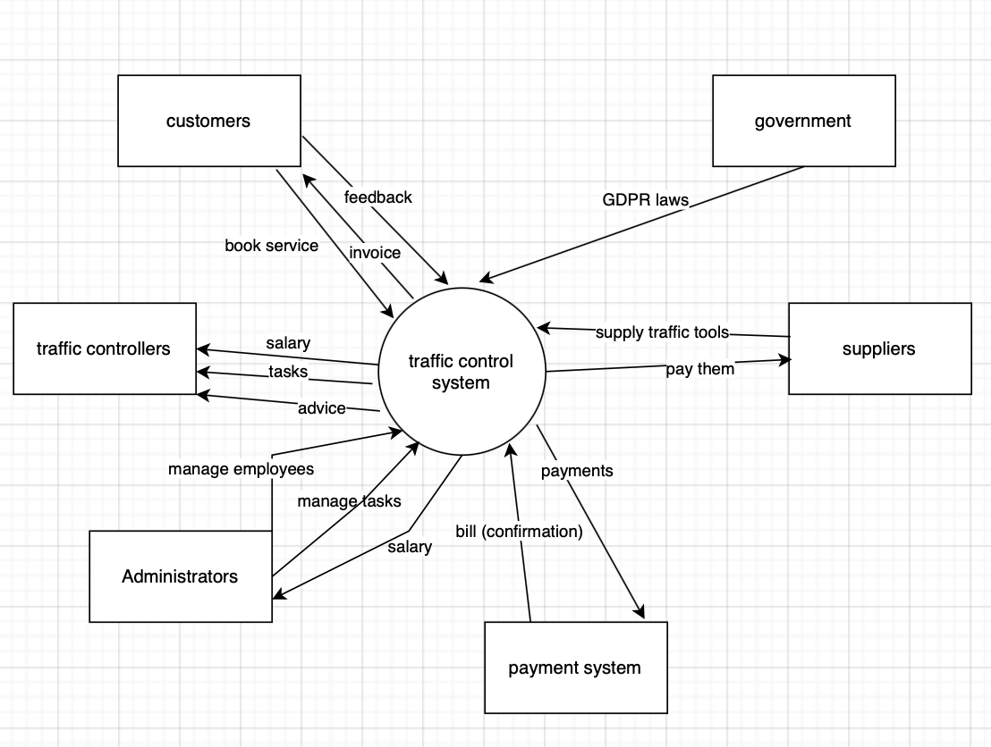

This diagram shows the fulfillment of the following requirements:

U16, U17, U18, U12, U23, U26, U38, F17, F22, F21, F18, U36, U37, U32, U33

## System architecture diagram:

To make the system scalable and accessible 24/7 we will use databases and API services.

The customer has access to a webserver through their computer or phone. Their webserver API is connected to admin page API. Administrator has access to an admin system and a database. Controller has access to application via phone.

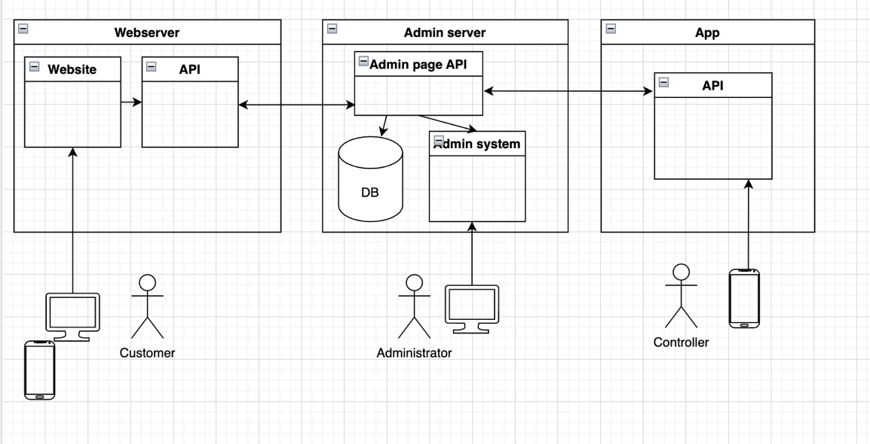

## Use case diagram + elaboration

The company contains five actors as can be seen in the diagram below.

Controllers can log in or register, view events, view announcements, and confirm the completion of the event. Furthermore, they can get a salary from Tim. Each administrator also receives a monthly salary from Tim, creates invoices, exports them to excel, and confirms bookings from customers. Customers can log in or register, book services, pay invoices by card, and even cancel bookings. The owner can pay salaries and sometimes give instructions to other workers. Finally, the government has their rules – GDPR laws, which Tim’s company should comply with.

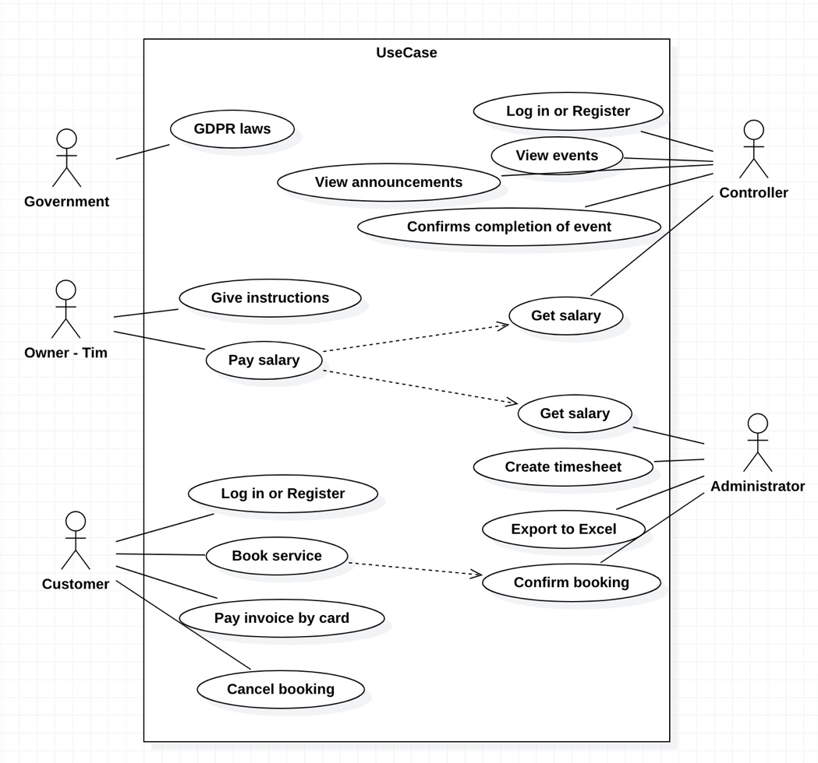

This diagram shows the fulfillment of the following requirements:

U6, U12, U18, U19, U21, U27, U20, U25, F18, F21, U36, U37, NF7, F19, F20, U32, U33, U35, B3, U36, U37, B2, F13.

|  |  |
| --- | --- |
| **Title** | Controller – Get salary |
| **ID** | Backlog item 5  User requirement: U25 |
| **Actors** | controller |
| **Preconditions** | controller must be logged in. |
| **steps** | * the system will display homepage menu. * controller should click on the "events" button. * the system will display all the upcoming events for the controller. |
| **Postconditions** | all the upcoming tasks are successfully displayed through the controllers app. |

|  |  |
| --- | --- |
| **Title** | Administrator – Export financial data |
| **ID** | Backlog item 4  User requirement: U35 |
| **Actors** | Administrator |
| **Preconditions** | financial data and invoices of customers are ready. |
| **steps** | * admin login. * the system displays the admin homepage. * admin should click on "timesheet" button In the toolbar. * system will display the timesheet. * admin should click on the "export financial data to excel" button on the toolbar. |
| **Postconditions** | the financial data is successfully exported to excel. |

|  |  |
| --- | --- |
| **Title** | Customer – cancel booking |
| **ID** | Backlog item 12  User requirement: NF11 |
| **Actors** | Customer |
| **Preconditions** | the user must already have booked a service. |
| **steps** | * the customer logs in to their homepage * they click on "your page" on the top right of their screen. * then click on "my orders" * all of their orders will be displayed on the screen. * there will be a "cancel" option next to each booking. * the customer clicks on the "cancel" button. * they will be directed to a different screen with a confirmation message that their order has been successfully cancelled. |
| **Postconditions** | the order is successfully cancelled. |

|  |  |
| --- | --- |
| **Title** | Controller – view events |
| **ID** | Backlog item 5  User requirement: U25 |
| **Actors** | Controller |
| **Preconditions** | controller must be logged in. |
| **steps** | * the system will display homepage menu * controller should click on the "events" button. * the system will display all the upcoming events for the controller. |
| **Postconditions** | all the upcoming tasks are successfully displayed through the controllers app. |

|  |  |
| --- | --- |
| **Title** | Controller – get/view salary |
| **ID** | Backlog item 8  User requirement: U26 |
| **Actors** | Controller |
| **Preconditions** | controller completed all tasks in his schedule. |
| **steps** | * login in the controller application * the system will display the homepage. * the controlled should click on: "salary" * the system will display the controller's salary for the current month. |
| **Postconditions** | the controller can successfully access their monthly salary through the application. |

## Domain model:

Our domain diagram consists of controllers, administrator, customer, salary, payment and event as can be seen in diagram below. 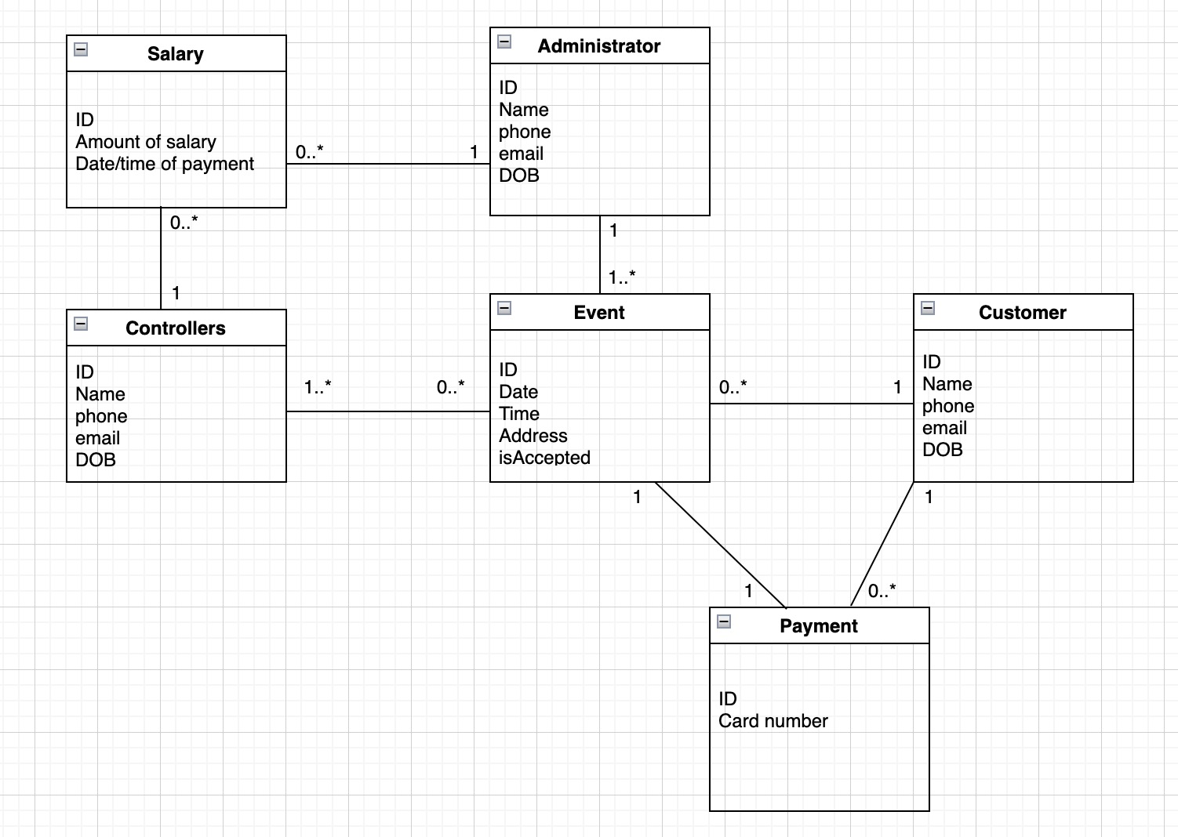This diagram shows the fulfillment of the following requirements:

U15, U16, U17, U24, U25, U26, U30, U38, U12.

A controller is responsible for 1 or more events, and a customer can have 0 or more events booked. An administrator manages one or more events. Each event is made by only one customer, and each event is managed by only one administrator. However, each event can be handled and accomplished by one or many controllers. Furthermore, each customer can have 0 or many payments to pay, and each event has one payment linked to it.

Each Salary is earned by only 1 controller or administrator, but each controller and administrator can have 0 or more salaries (0 if they recently joined the job and do not have any salaries yet).

## Activity diagram:

*Creating an event:*

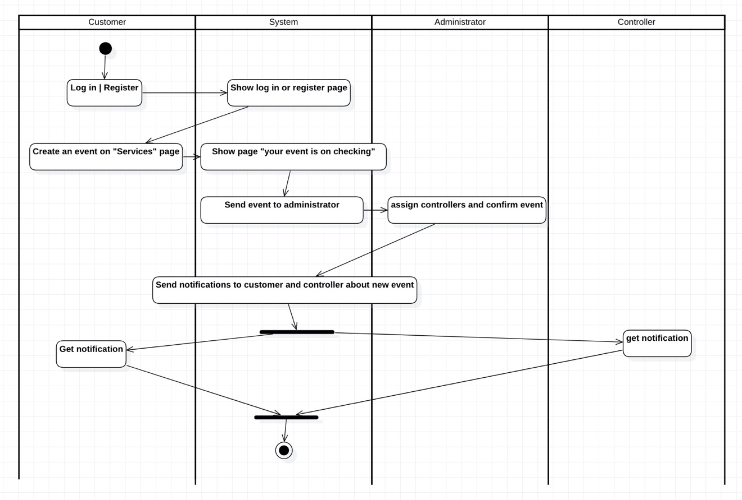

This diagram shows the fulfillment of the following requirements:

U6, U8, U4, U16, U33, U36, U37.

In the process of creating an event, the customer must first click on the register or login button, the system will display the login or register page, then the customer would login and click on the services button and create an event on the services page, the system will then display a message saying, “you event is on checking” and send the event to the administrator, the administrator will then assign the event to controller and confirm the event. Once the event is confirmed the system will end a notification to both the customer and the controller simultaneously. And finally, both the controller and customer will receive a notification and then the process ends here.

# User stories

## All user stories with effort:

## All sprint 1 user stories:

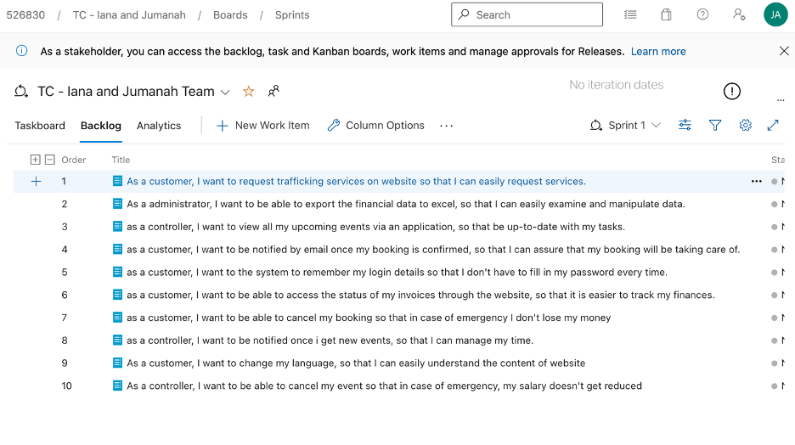

## 14 Elaborated user stories:

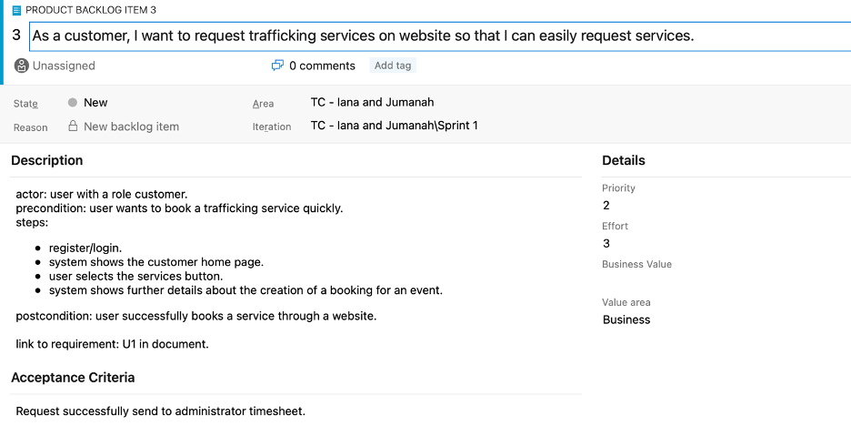

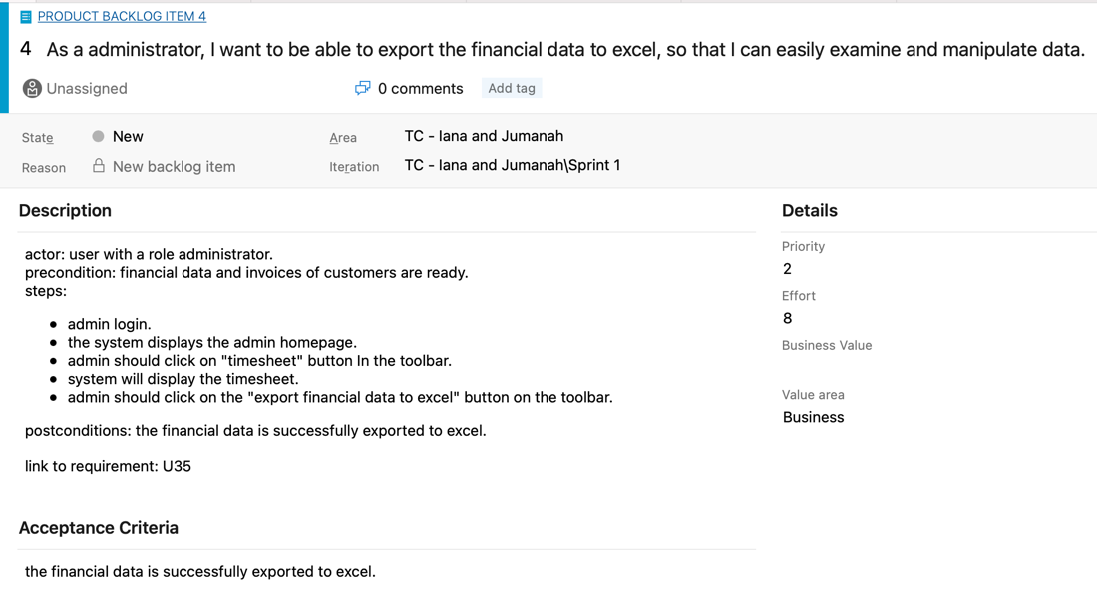

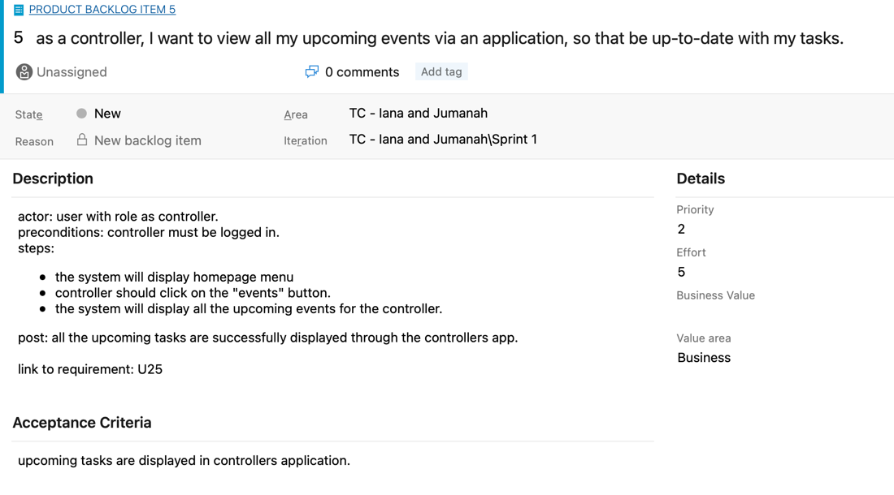

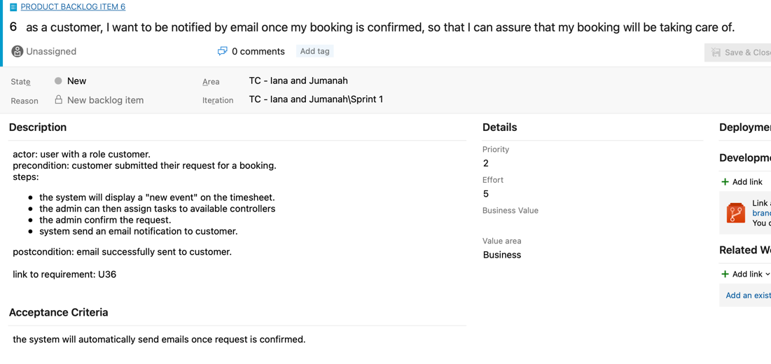

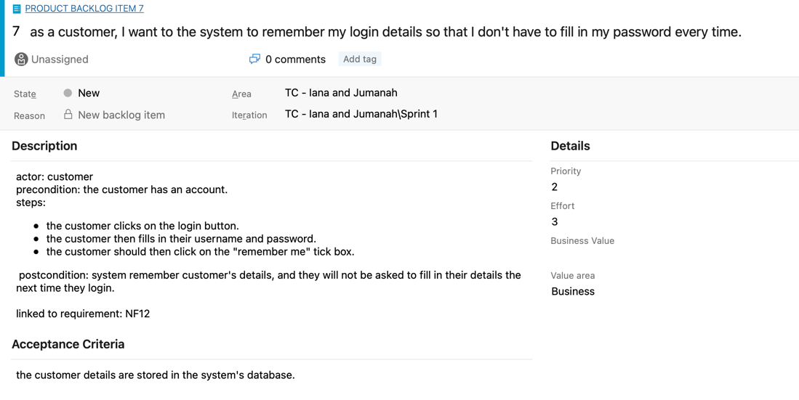

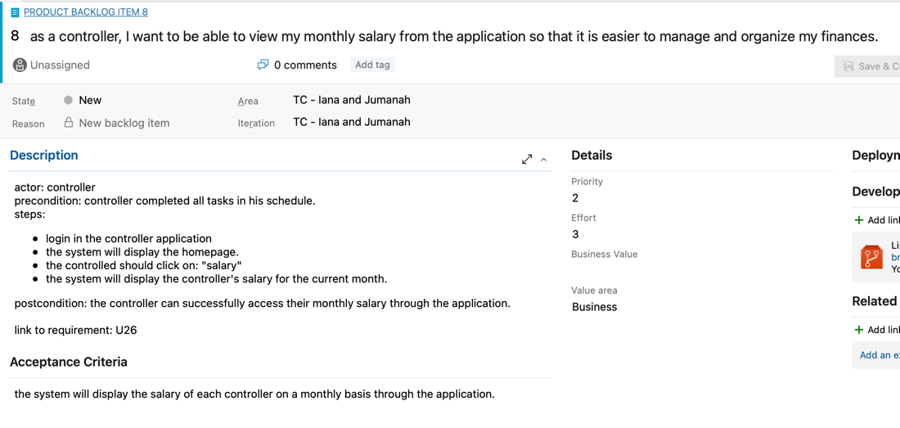

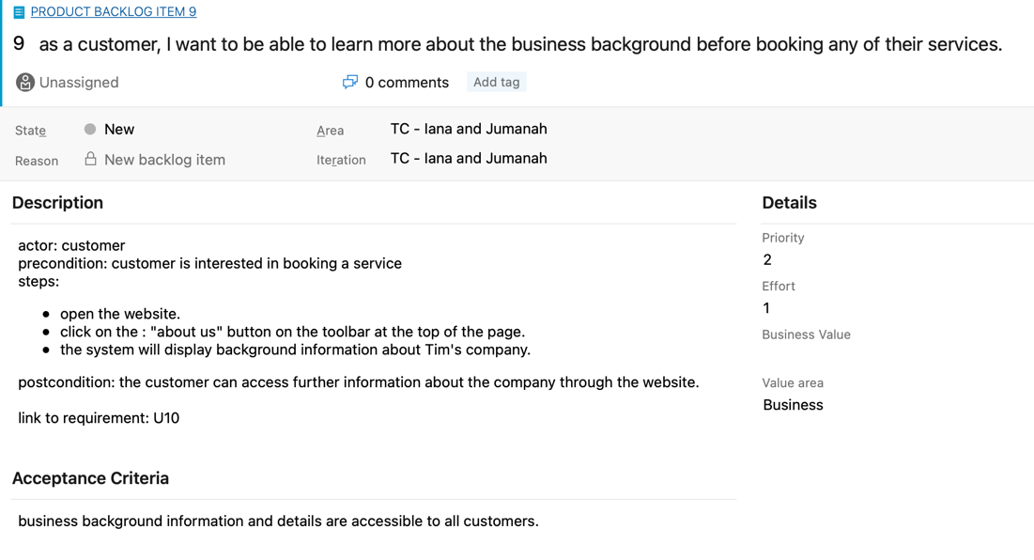

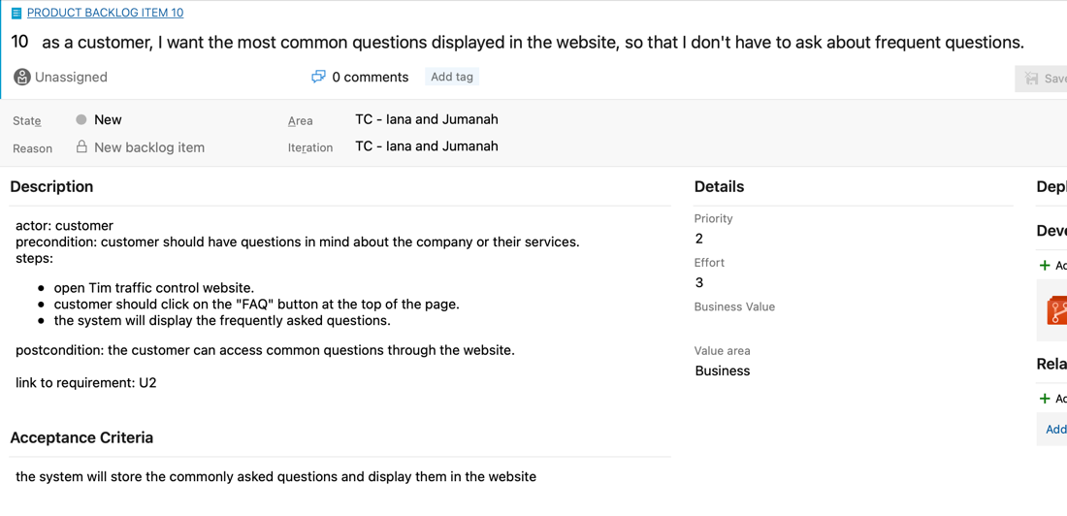

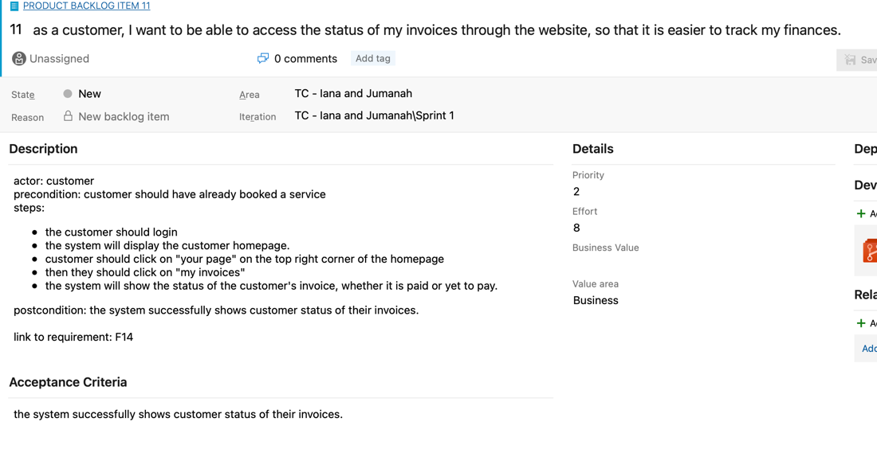

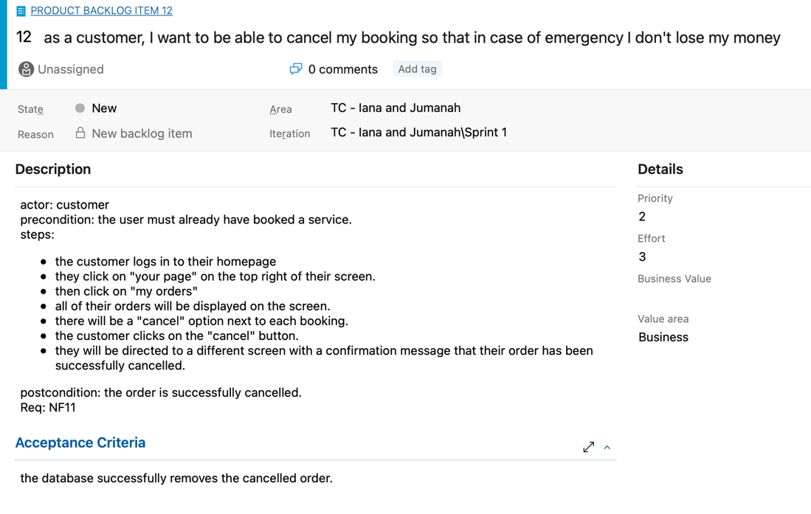

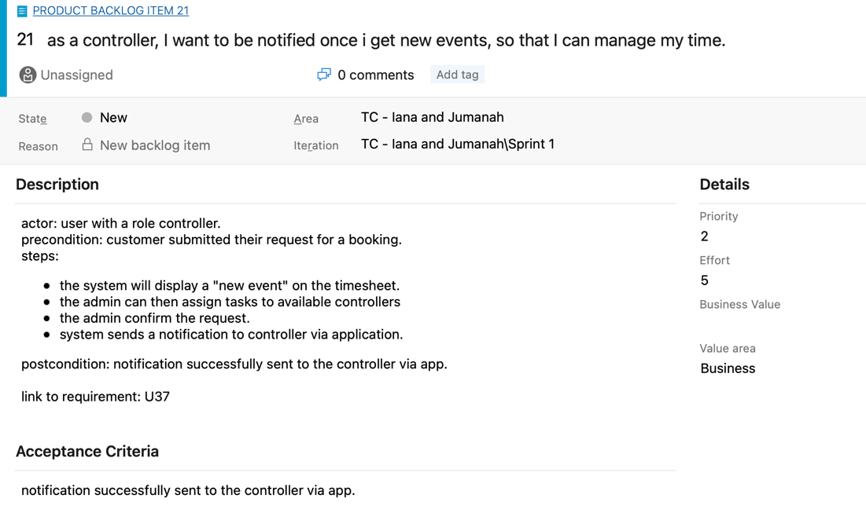

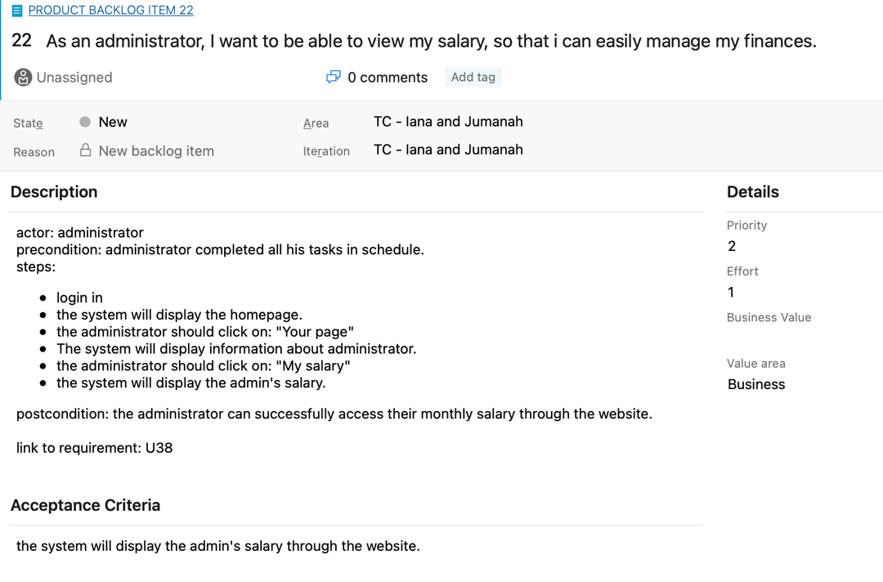

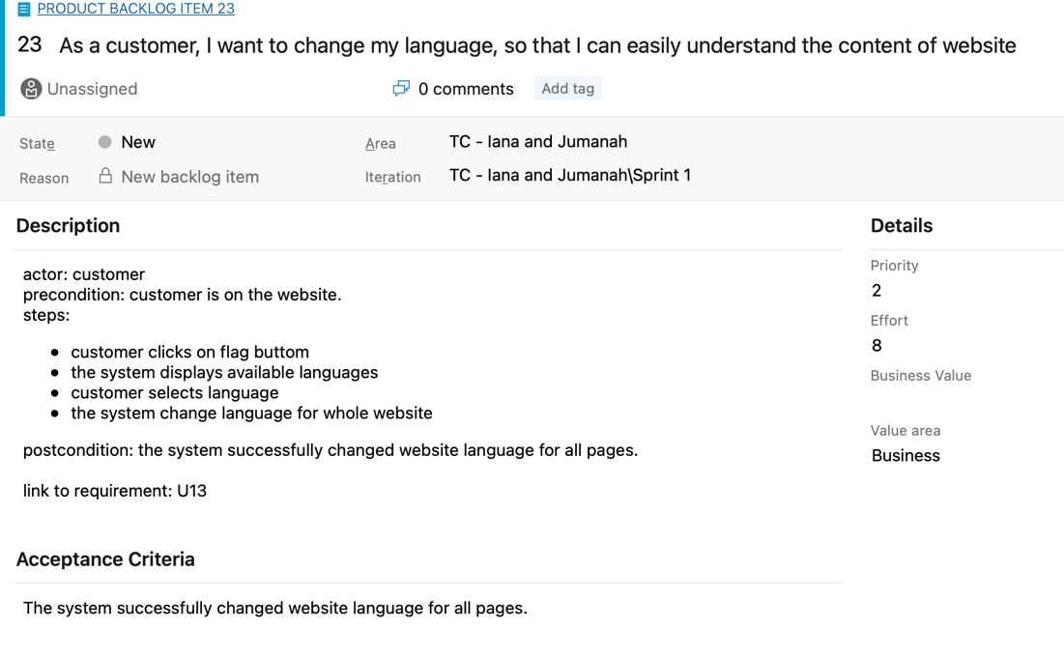

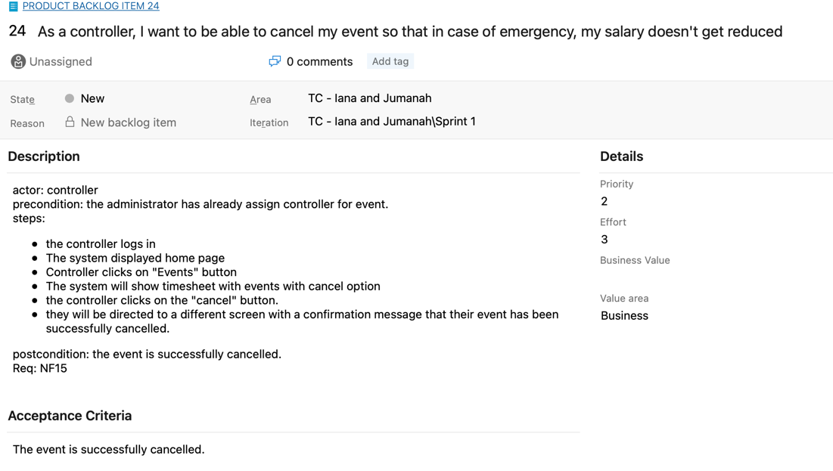

# Test cases:

**HP** – happy path

**UP** – unhappy path

**B** – boundary value

**Number after –** linked to user stories

## All test cases:

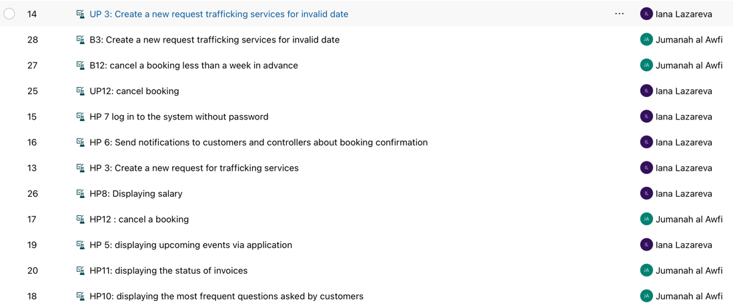

## Elaborated test cases:

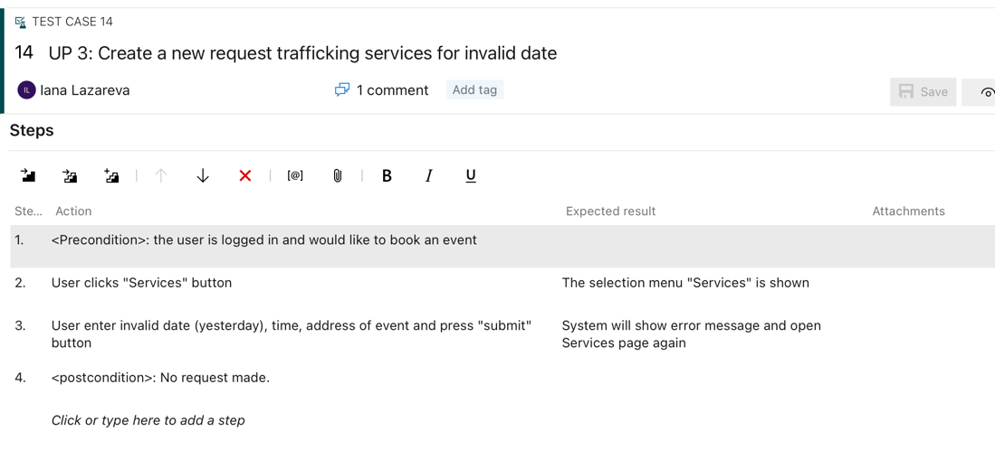

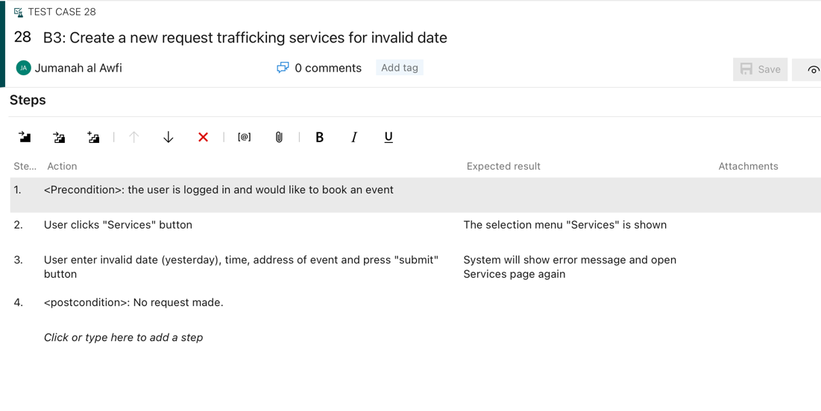

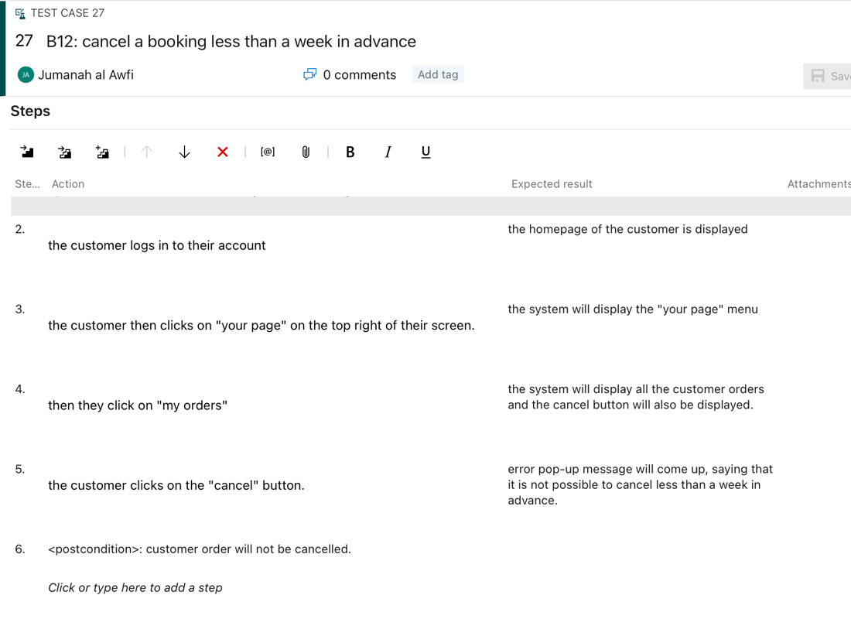

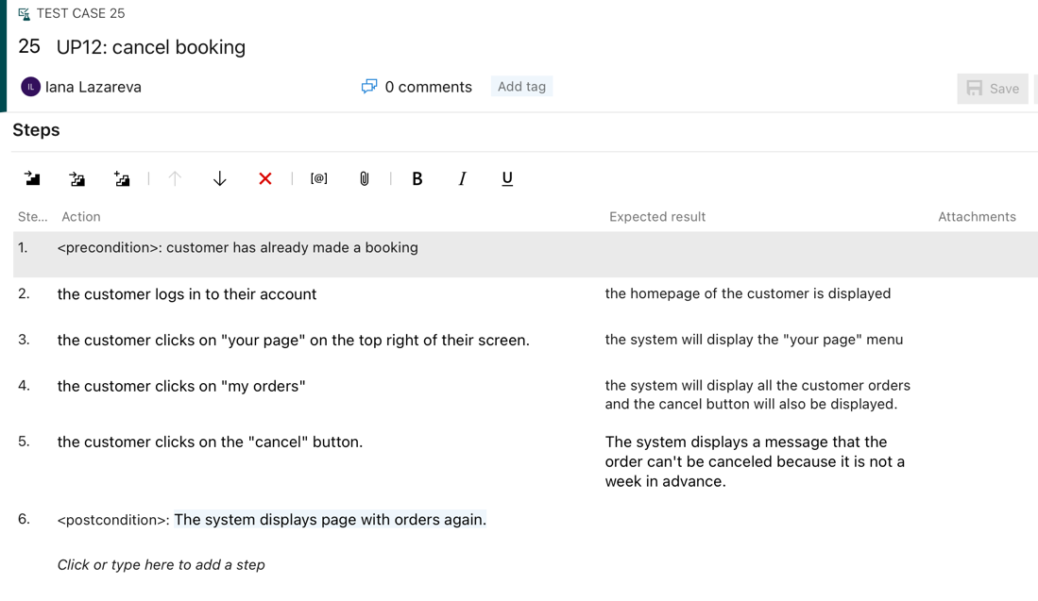

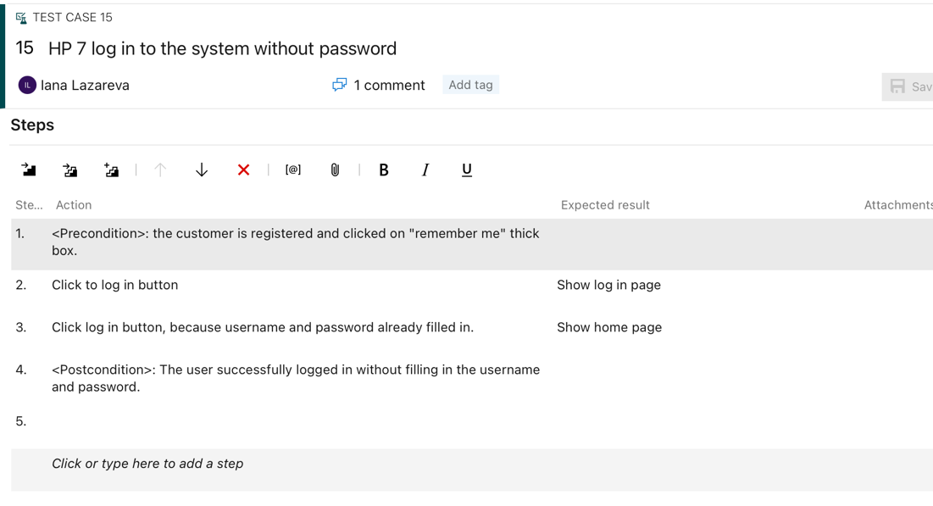

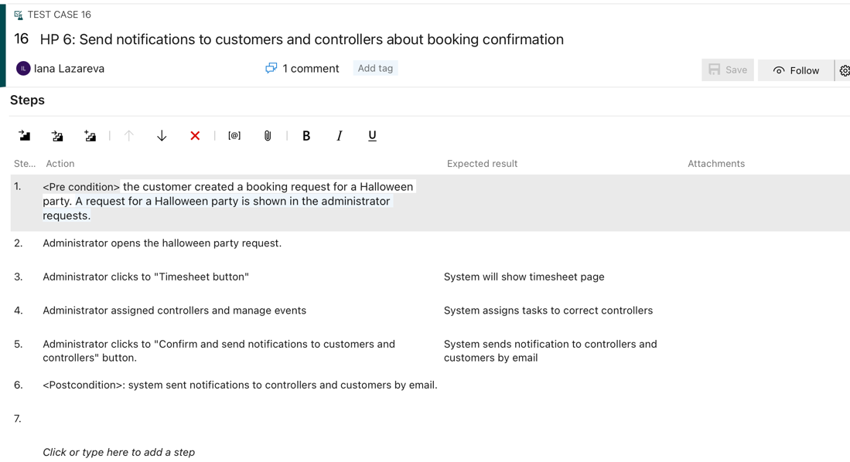

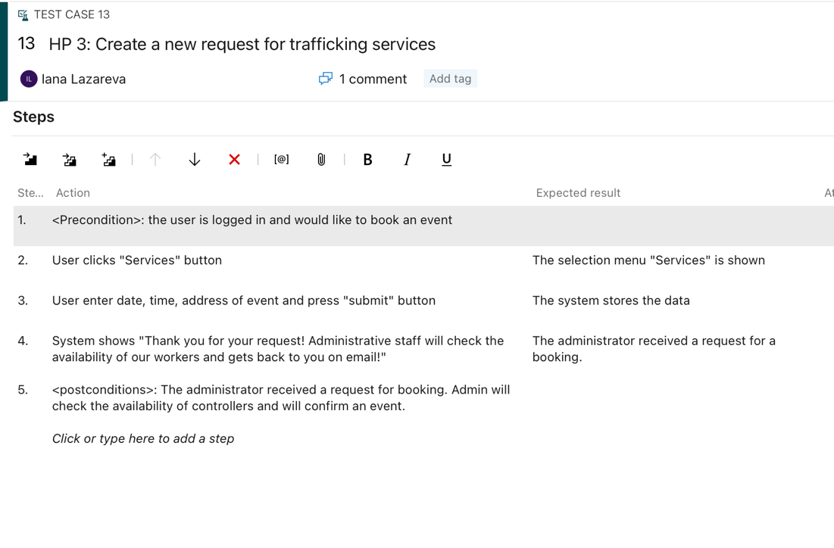

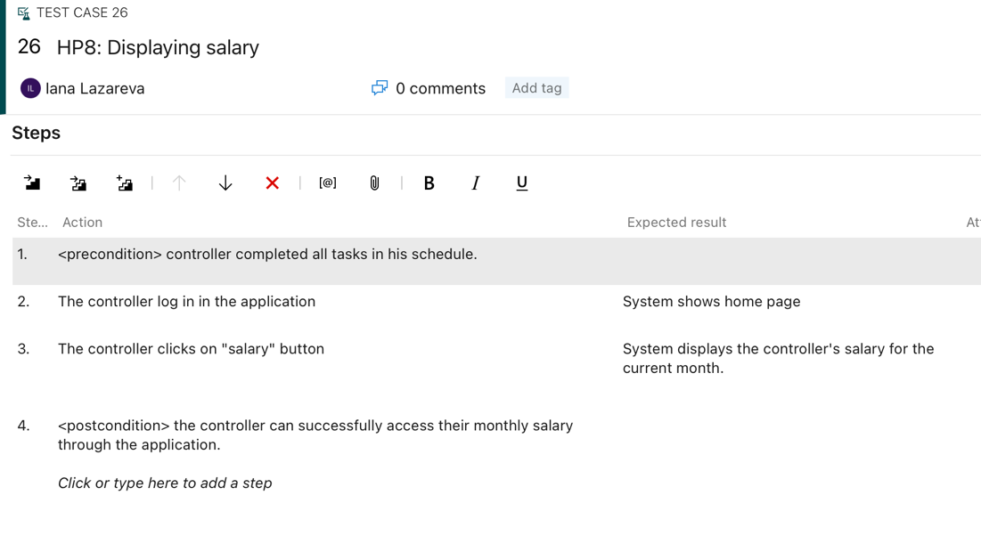

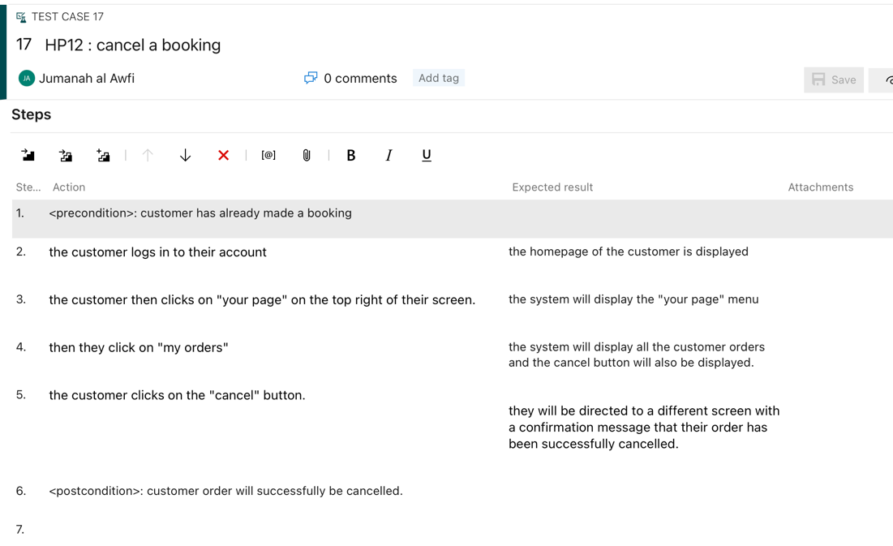

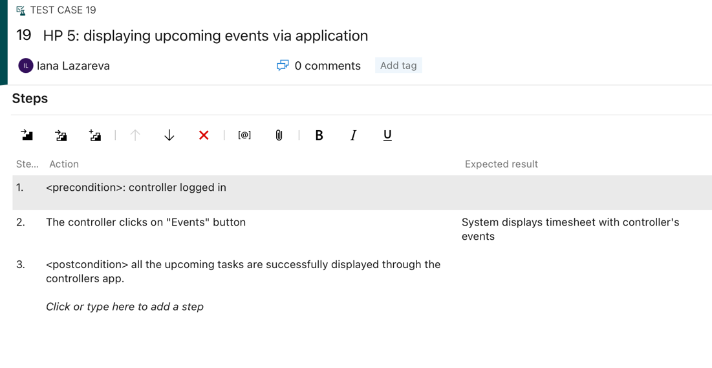

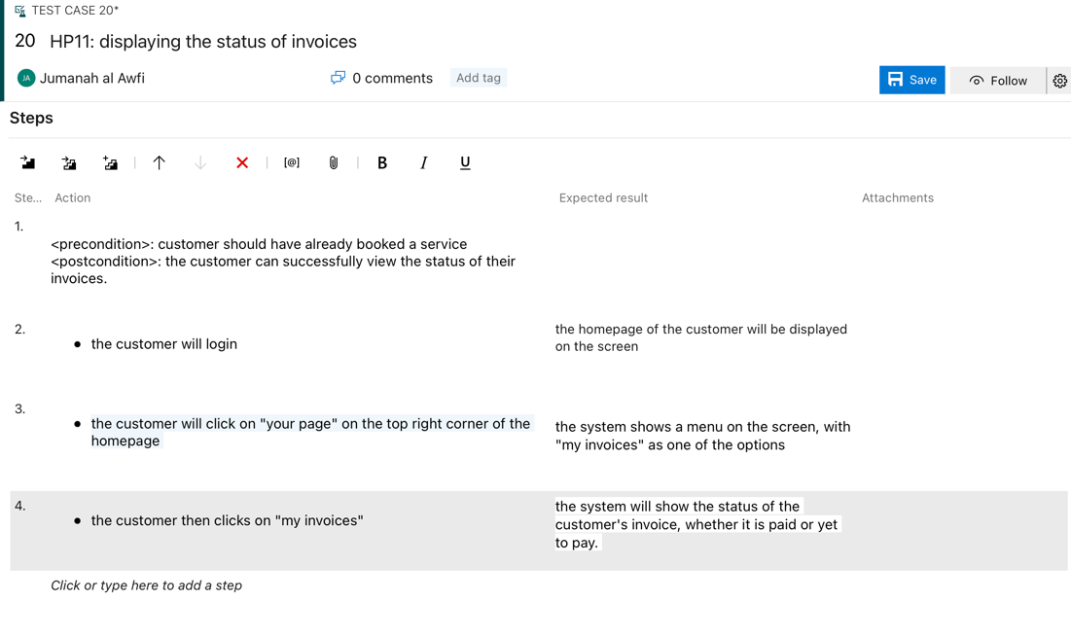

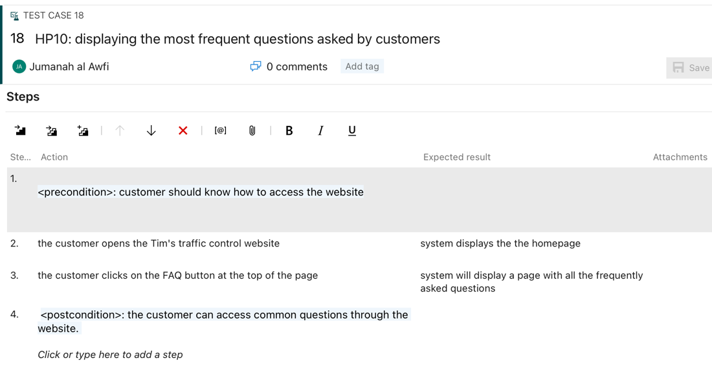

## Traceability matrix

Below is traceability matrix. The matrix describes what requirement is tested by which tests.

|  |  |  |  |  |  |  |  |  |
| --- | --- | --- | --- | --- | --- | --- | --- | --- |
| Requirement Test | U1 | U2 | U25 | U36 | NF12 | U26 | F14 | NF11 |
| HP 3 | X |  |  |  |  |  |  |  |
| UP 3 | X |  |  |  |  |  |  |  |
| B 3 | X |  |  |  |  |  |  |  |
| HP 5 |  |  | X |  |  |  |  |  |
| HP 6 |  |  |  | X |  |  |  |  |
| HP 7 |  |  |  |  | X |  |  |  |
| HP 8 |  |  |  |  |  | X |  |  |
| HP 10 |  | X |  |  |  |  |  |  |
| HP 11 |  |  |  |  |  |  | X |  |
| HP 12 |  |  |  |  |  |  |  | X |
| UP 12 |  |  |  |  |  |  |  | X |
| B 12 |  |  |  |  |  |  |  | X |

*Table Traceability Matrix*

# Wireframes:

____________________________________________________________________________

## For customer:

<https://quant-ux.com/#/test.html?h=a2aa10aR5La4Y7B2Ms3Elrs2dxruOj908lX1upteKaXrsw489fROnm7SqzqW>

____________________________________________________________________________

## For administrator:

<https://quant-ux.com/#/test.html?h=a2aa10aS3KmJoryxvCuopQuefa5quQ1FBIP9H9XQUzNrew0LGVCiVRFDn6Om>

____________________________________________________________________________

## For controller:

<https://quant-ux.com/#/test.html?h=a2aa10akl6DRMqwORQErUzeW9nH0egmIO9FnyvChhkqnt3N0PGDfJxym5y4K>

# Appendix A

Interview questions:

1 week controllers

Customers fee – increases full amount,, 1 week

* Can controllers cancel(manage) their events? - more than a week in advance. Also in emergency – phone to the administrator
* How can controllers contact Tim in case of emergency? (maybe chat in application). And how customers can contact your business? --own department whatsapp and call if emergency
* Can customers rent or buy traffic equipment? --no.
* Can potential employee apply to the job through the website? No.
* Does your business have any social media accounts?yes.
* Do you want to have a section “employee of the month”? Yes. Top 3.ber.
* Would you like to have a “News” section. Yes.
* Tick box for having evengt shared publicly. Gdpr rules

IF WE HAVE TIME

* Administrative staff want to export to excel timesheet with all customers or for one customer or both options should be included?
* What the latest and earliest time that a client can book? (when does the business close at night? -> so we can set boundaries and limits when the customer tries to book at a time that is not possible—for example midnight)
* Do controllers, admins have a fixed wage?
* Key for tasks.
* Remove pay tax

Interview 1:

* Admin website + app for employees
* Easier for mobile devices - for onsite workers but for desktop ppl sp maybe app
* German, Dutch(must), English, turkish
* Software employees time register

How often to invoice and salaries ?

* invoice asap client Some
* regular client's monthly
* employees monthly
* Solve the problem of lost and late timesheets need it asap
* no fill in - in timesheet, it's already in planning
* Separate pages
* employees not see customers and vice verse and admin as well
* Customer request event and hours, government regulations
* Employees max hours is 10
* Phones employees
* Authentication method?
* Better and faster methods to authenticate not password everytime
* Once password but then no longer need to put password everytime, but another authentication method
* Admin more security with authentication
* Authenticate device once (remember me)
* Planning system:
* Weekly
* Monthly schedule but weekly updates
* Cancel a week before
* Employees know where to go
* Client don’t know about details of employees they just know that they will show up.
* No cash,
* Not necessarily directly after
* No PayPal
* As long as it’s secure
* account and their service with adds for customers
* Central way to request services
* Public platform for requests

Design:

* Pretty
* Easy
* Logo
* we decode on platform
* Employees - laptop
* On site employees - phone
* Chat not and Frequent asked questions
* To avoid stupid questions

Additional equipment for invoices: for sites

* Electricity
* Toilets
* Month in advance for holiday so he doesn't allocate them to tasks
* Chat for employees - not important
* Announcements - notify employees for schedule changing.
* Guide for employees (for nut disturbing Tim)
* Employees should write their phone numbers, when register
* Different admin for different things
* Certain Admin for sick ppl
* Progress graphs
* Data to client
* Invoice: number of people, hours, need to know where the money is spent no details.
* Final conclusion of it is in excel file. (Export to excel)(Final invoices and salaries in excel)
* Employees can’t know anything about invoices,
* Only administration know it.
* Clients don’t know details of employees
* Security for data not in excel since its not secure…?
* After a week the cancellation is without a refund.